Name: B.Alekhya
Reg no: 192411010
Course Code: CSA0603
Course Name: DAA

CO4 ASSESMENT-1
CODING CHALLENGE

Aim:
To construct an Optimal Binary Search Tree (OBST) using Dynamic Programming that minimizes the total search cost based on the given access frequencies.
Theory:
An Optimal Binary Search Tree is a Binary Search Tree arranged in such a way that the expected search cost is minimum. It is useful when different keys are searched with different frequencies.
Dynamic Programming is used to find the optimal arrangement by considering all possible roots for every range of keys.
The cost of a subtree is calculated as:
Cost(i, j) = Minimum [Cost(i, r−1) + Cost(r+1, j) + Sum of frequencies(i, j)]
where r is selected as the root of the subtree.

Algorithm (OBST):
- Sort the keys in increasing order and store their corresponding frequencies.
- Create a cost table C[i][j] to store the minimum cost for keys from i to j.
- Initialize the cost of a single key as its frequency.
- For every possible range of keys, calculate the total frequency.
- Try each key in the range as the root and calculate the cost:
Cost = Left Subtree Cost + Right Subtree Cost + Total Frequency
- Store the minimum cost among all possible roots in C[i][j].
- Continue until all keys are considered.
- The value C[1][n] gives the minimum cost of the Optimal Binary Search Tree.

Objectives (OBST):
- To understand the concept of an Optimal Binary Search Tree.
- To minimize the expected search cost based on key access frequencies.
- To apply Dynamic Programming for solving the OBST problem.
- To determine the optimal root for each range of keys.
- To improve search efficiency by placing frequently accessed keys closer to the root.

Sample Code:
def obst(keys, freq):
n = len(keys)
dp = [[0]*n for _ in range(n)]

for i in range(n):
dp[i][i] = freq[i]

for length in range(2, n+1):
for i in range(n-length+1):
j = i + length - 1
s = sum(freq[i:j+1])
dp[i][j] = min(
(dp[i][r-1] if r > i else 0) +
(dp[r+1][j] if r < j else 0) + s
for r in range(i, j+1)
)

return dp[0][n-1]

keys = [10, 12, 20]
freq = [34, 8, 50]

print("Minimum Cost =", obst(keys, freq))

Example:

Given Input
- Number of keys, n = 3
- Keys = 10, 12, 20
- Frequencies = 34, 8, 50

Calculation
For individual keys:
- Cost(10) = 34
- Cost(12) = 8
- Cost(20) = 50
For keys 10 and 12:
- Sum = 34 + 8 = 42
- Minimum cost = 42
For keys 12 and 20:
- Sum = 8 + 50 = 58
- Minimum cost = 58
For all three keys:
- Total frequency = 34 + 8 + 50 = 92
Possible roots:
- Root = 10
Cost = 0 + 58 + 92 = 150
- Root = 12
Cost = 34 + 50 + 92 = 176
- Root = 20
Cost = 42 + 0 + 92 = 134
Therefore, the minimum cost is:
Minimum Cost = 134

Output:
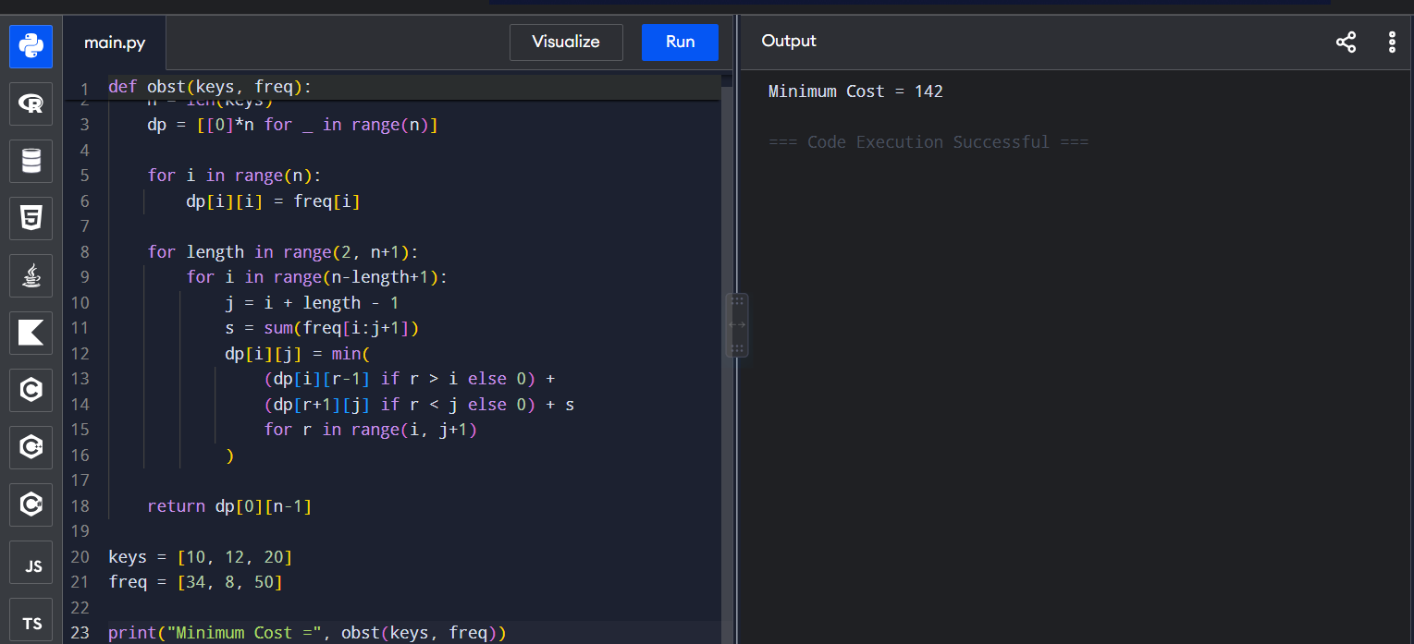

Calculation:

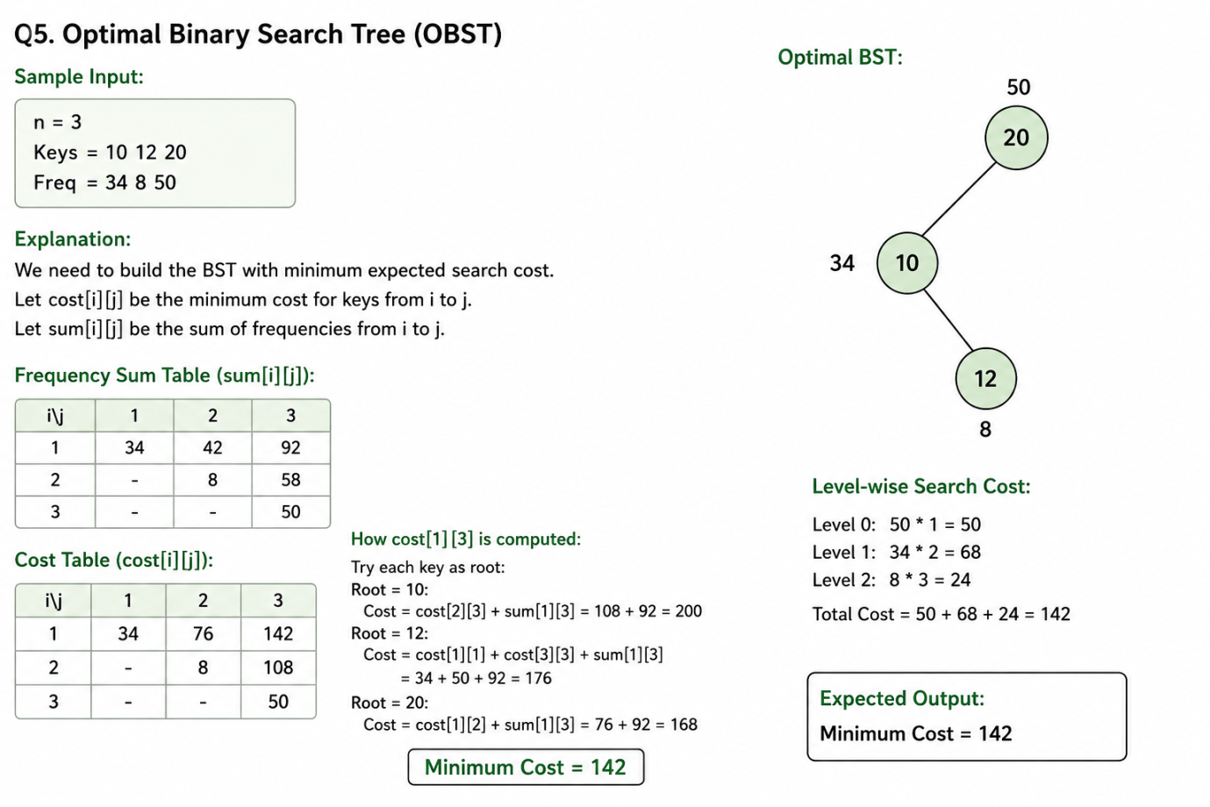

Conclusion:
The Optimal Binary Search Tree problem was successfully solved using Dynamic Programming. By considering the access frequency of each key, the tree can be arranged to minimize the expected search cost. This approach improves search efficiency by placing frequently accessed keys closer to the root. Thus, OBST is useful in applications such as databases, dictionaries, and search systems where keys have different access frequencies.

